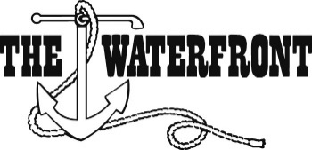

37th Annual WMGA Men’s Member-Guest Entry Form June 14th – 16th
Non-Refundable Cancellation Deadline is May 29th

General Information
You are cordially invited to participate in the 2018 Men’s Member-Guest Golf Tournament. We are looking forward to an exciting and enjoyable event. This year’s match play tournament will be played over the course of three days. Playing one 9-hole match on Thursday, two 9-hole matches on Friday and two 9-hole matches on Saturday. The entry fee is $700 per team and is limited to 48 teams.

Please RSVP by returning the entry form to the golf shop in person, emailing, (mmckee@thewillardcompanies.com) or mailing it directly to Mark McKee, PGA at The Waterfront Country Club, 275 Anchor Dr, Moneta, VA 24121. Forms must be received by the NON-REFUNDABLE date of May 29^{th.}

The 2018 tournament is sure to be a memorable experience. Please feel free to contact us at (540) 721-2653 with any questions you may have. We look forward to your participation.

Member-Guest Information
Member Name:
Member Number:
Guest Name:
Guest GHIN #:
Guest Address:
Guest Club Where Handicap is Held:
Guest Email:

Additional Information
NOTE: If a player does not have an established handicap at a club, the player will need to present ten attested scorecards to Mark by Thursday, June 1st. ALL handicaps are subject to adjustment by the committee.

To help the committee with its planning, please indicate the number who will attend the following events:

Thursday – Stag Party (Players Only)
Friday – Cocktail & Dinner Party (Players and Spouses)

